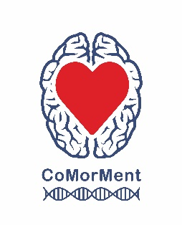
Stratified Medicine

In the future, doctors may use DNA tests to help them decide
which medicine to prescribe. This process of splitting people into different treatment groups is called ‘stratified medicine’.

Paper Chain People
- Fold your paper concertina style (back-and-forth)
- Draw a person shape on the front. Make sure the hands and feet extend off the edge
- Cut out and unfold to make a chain of people. Do not cut across the hands or feet.
How many people will you make?
Our researchers study mental illness.
- 1 in 4 people experience mental health issues each year.
- 1 in 3 people will experience symptoms of anxiety or depression in their lifetime.



- Add some DNA to each person.
You could use stickers or pens. Try using a few different colours to make a pattern.
DNA is like a recipe or set of instructions.
It tells the cells of the body what to do.
  - For some things (e.g. eye or hair colour) there is a clear set of instructions.
  - However, for others (e.g. height), DNA has an influence, but how tall you grow will depend on other things too (e.g. diet).
  - Sometimes, a change in just one gene can lead to a health condition (e.g. cystic fibrosis). But more commonly, especially for mental ill-health, numerous genes are involved, and the final outcome will be influenced by many different things - including lifestyle and stressful life events.
In the future, doctors may use DNA tests, to help them decide which medicines to prescribe.
In this picture:
- The person on the left has mostly blue stickers, so would respond best to the blue medicine.
- The person in the middle has mostly yellow stickers, so the yellow medicine would be best.
- The person on the far right has a mixed pattern, so the genetic test may not be informative. The doctor may need to look elsewhere for clues.


- Turn over your paper chain people and decorate them.

What colour will their eyes and hair be?

As well as DNA, our researchers also look at lifestyle factors – what people eat, what sports or activities they do etc. Maybe your people could be carrying some food or sports/art equipment?

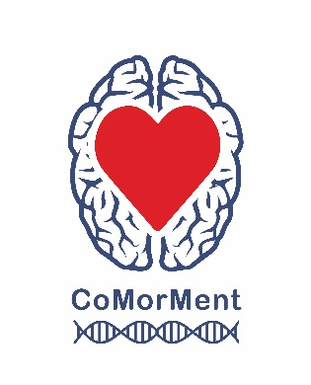
CoMorMent researchers work with ‘Big Data’ which means they combine together DNA, lifestyle and other clues from
1.8 million people. Some of these people have mental ill-health, some have cardiovascular disease; some have both, some have neither.
By looking at the patterns, they hope to develop a tool or test that can help predict whether or not a person with mental illness is likely to develop cardiovascular disease (i.e. who is at high risk?)
In the future, doctors could use this test to help them decide which medications or interventions to give to a person with mental ill-health. If the test suggests they are at high risk of developing cardiovascular disease, perhaps a different medication will be chosen, or regular testing will be recommended. This is stratified medicine.

Share a photo of your paper chain people with us on Twitter: @CoMorMent
Find out more about our research on the CoMorMent Website

Example: Stratified Medicine for anti-depressant prescribing



At the moment, doctors tend to prescribe the most common types of anti-depressant first.
If that doesn't work or the patient experiences too many side effects, the doctor will try another option. This process may of trial and error could be repeated for months or even years before the most appropriate medication is found.

In the future, we may be able to give people a DNA test and use the results to help us prescribe that person the most appropriate medicine (for them), the first time around
(see flow charts below).

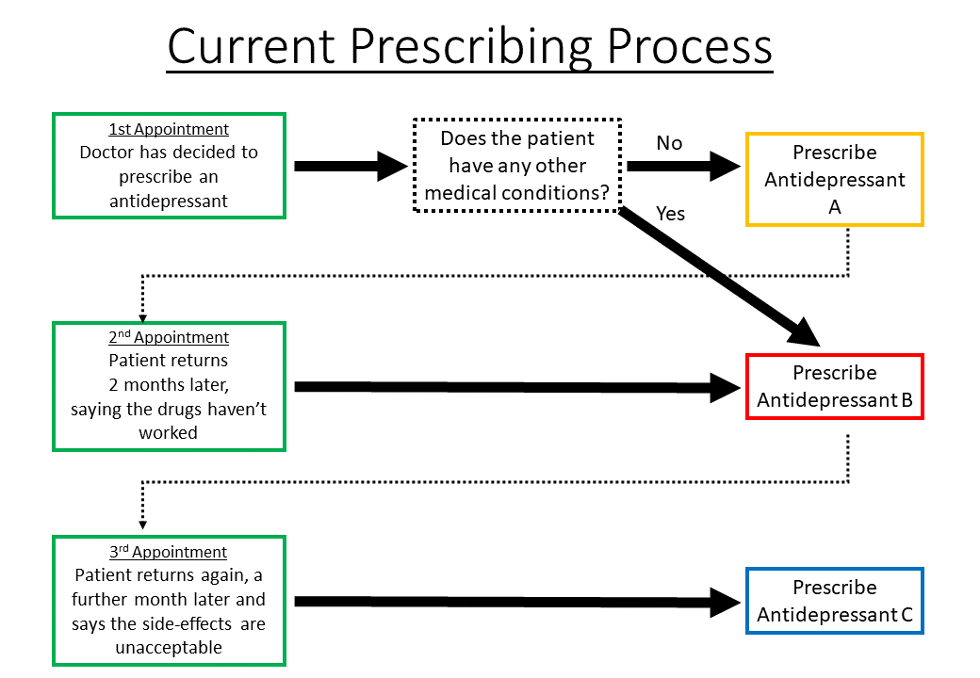
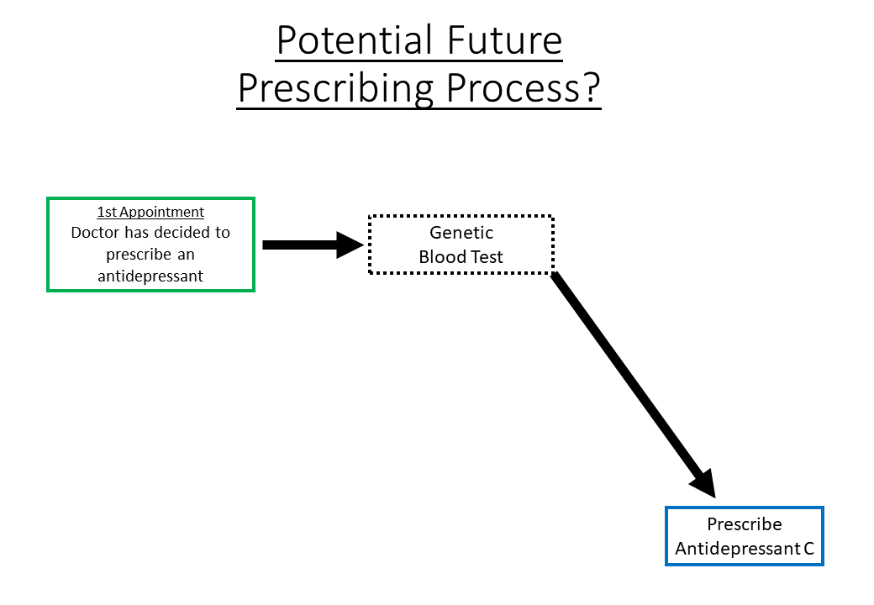
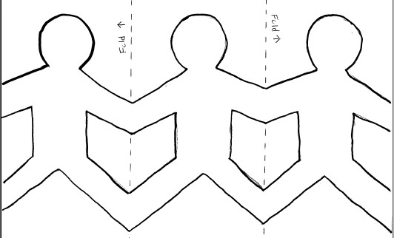

Mental Health Taskforce NE. The Five Year Forward View for Mental Health. 2016. Available from: england.nhs.uk
GLAD Study of Anxiety and Depression. Available from: https://gladstudy.org.uk/about/

